Day 9 Dictionaries nesting and the secret auction program

<https://www.udemy.com/course/100-days-of-code/learn/lecture/19279336#overview>

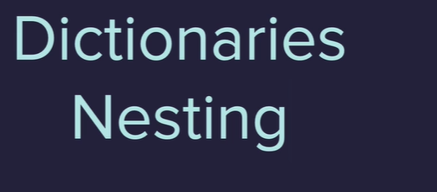

Dictionaries in python kind of like a real dictionary

-group together and tag related pieces of information

key value table

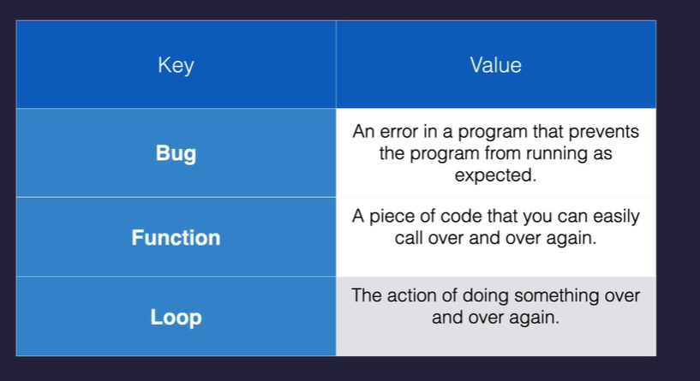

Syntax to create a dictionary

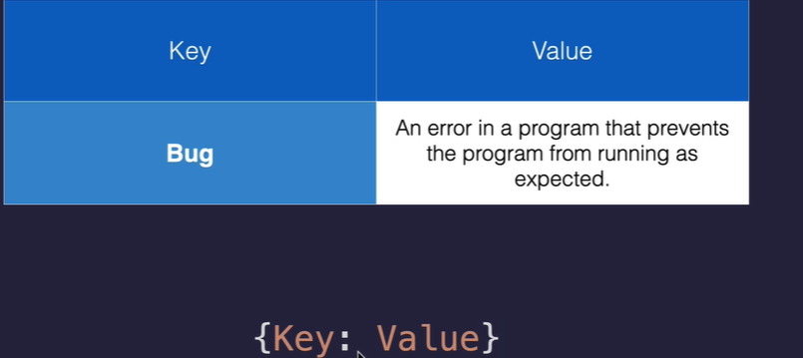

Becomes 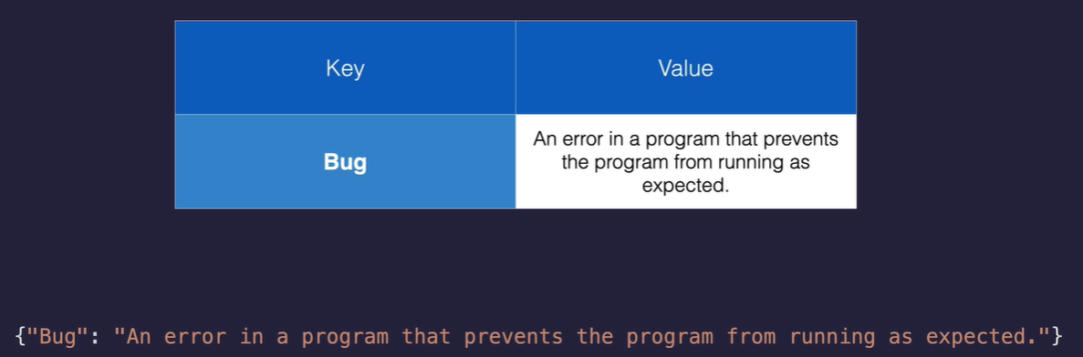

Add additional entries to the dictionary with a comma

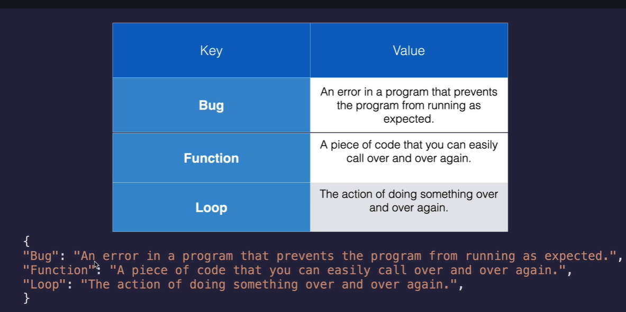

Need to use the correct data type so Bug is a string

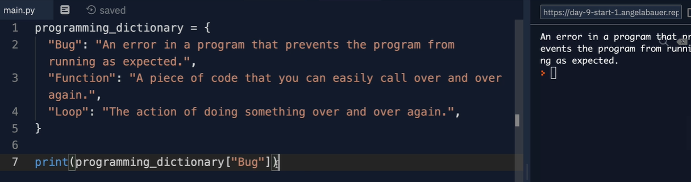

To add to the dictionary 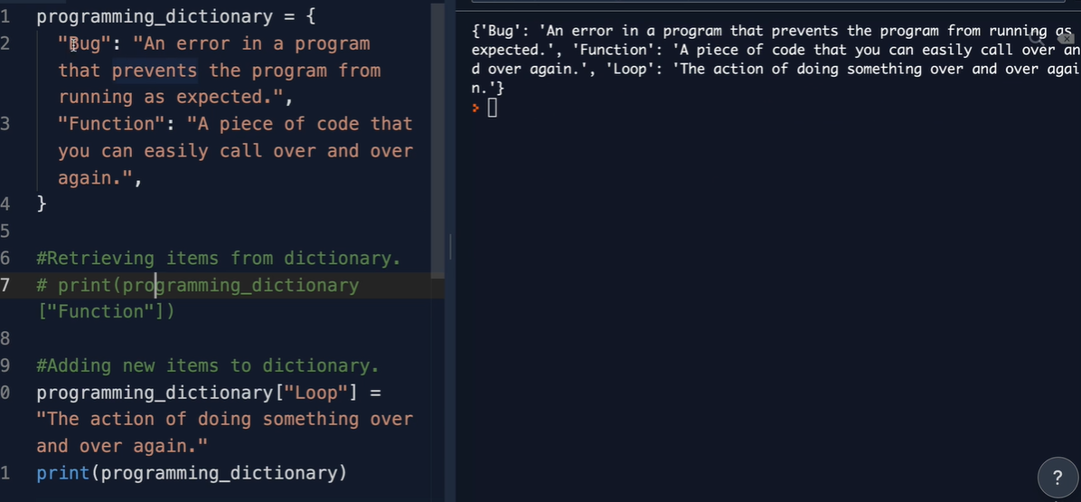

Edit item in dictionary

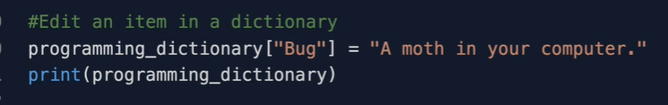

Build a grading program

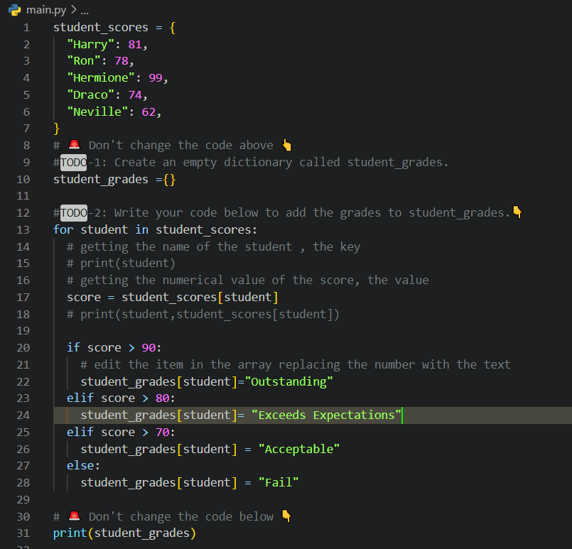

Nesting lists in Dictionaries

List or Dictionary like folder with stuff inside – folder in a folder

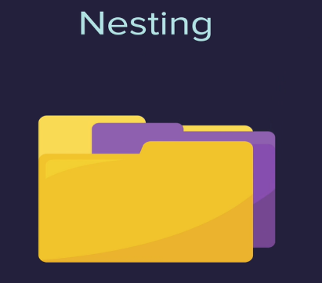

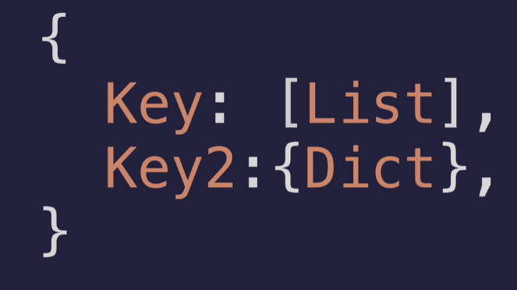

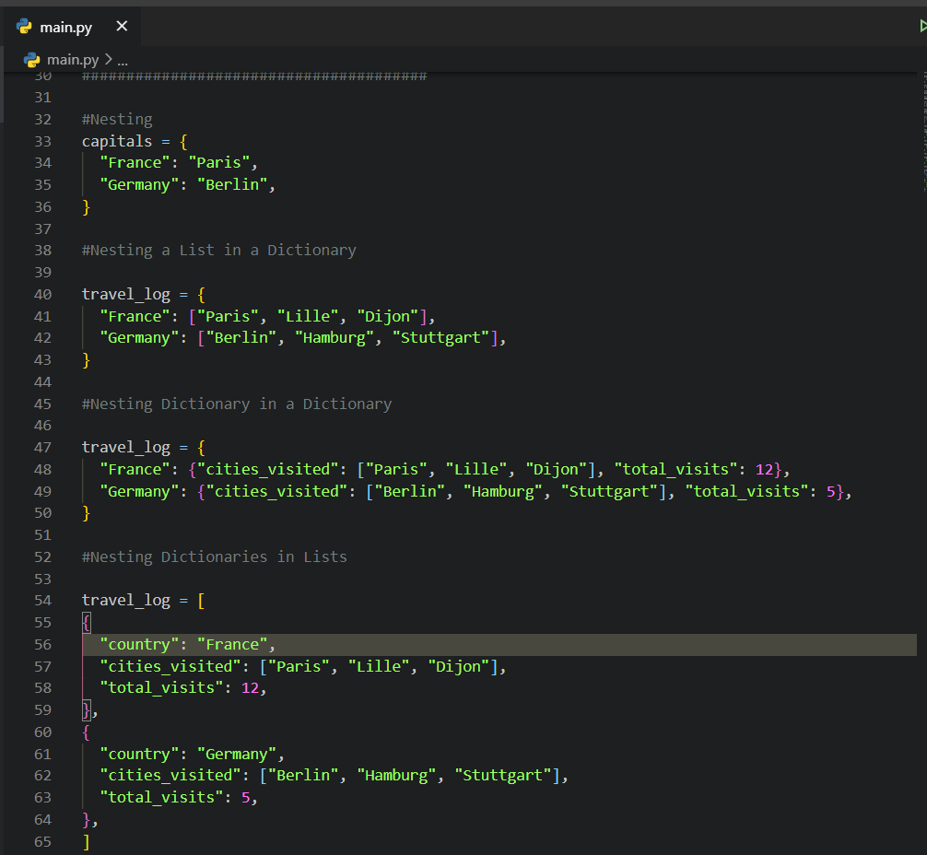

Restart with coding exercise 92

<https://www.udemy.com/course/100-days-of-code/learn/lecture/19279378#overview>

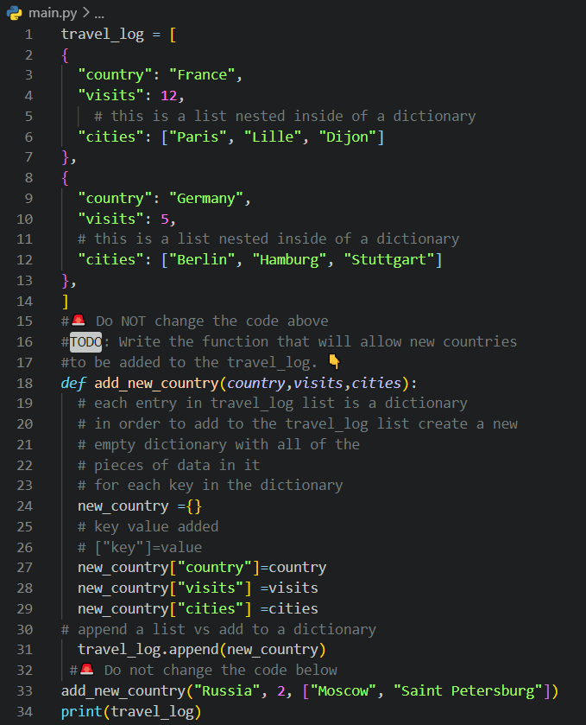

Secret Auction Program

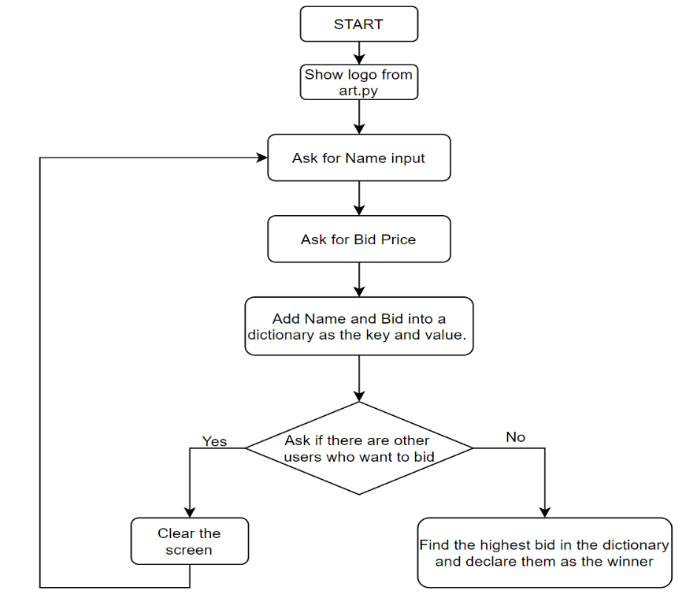

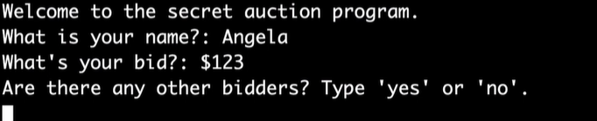

Use clear() to clear 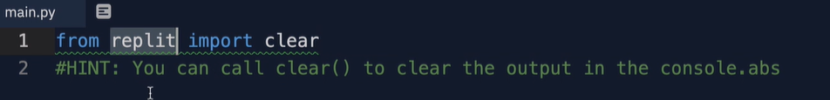

Create a dictionary with these key value pairs 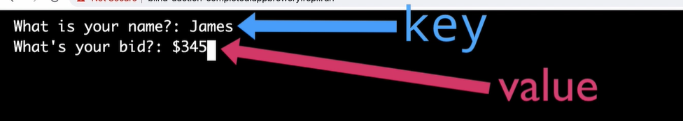

Add each bidder to the dictionary

When no is answered loop through to find the highest bidder